Notes and task on AWS WAF-01
1. AWS WAF
AWS WAF Documentation
What it is
AWS WAF (Web Application Firewall) protects your web applications from common web attacks at the application layer (Layer 7).
It filters and monitors HTTP/HTTPS requests going to:
- Amazon CloudFront
- Application Load Balancer (ALB)
- Amazon API Gateway
- AWS App Runner

What attacks it blocks
Examples:
- SQL Injection (SQLi)
- Cross-Site Scripting (XSS)
- Bad bots
- IP reputation attacks
- HTTP flood attacks
- Geographic blocking
- Rate limiting

Key Features
- Web ACLs (Access Control Lists)
- Managed rule groups
- Custom rules
- CAPTCHA and challenge responses
- Rate-based rules
- Bot Control

Example
If someone sends:
' OR 1=1 --
in a login form, AWS WAF can detect and block it.

2. AWS Shield Advanced
AWS Shield Advanced Overview
What it is
AWS Shield Advanced is a managed DDoS protection service.
It protects against:
- Network layer attacks (Layer 3/4)
- Transport attacks
- Large-scale DDoS attacks
- Sophisticated application attacks

Difference Between Shield Standard and Shield Advanced
Feature | Shield Standard | Shield Advanced
Included by default | Yes | No
Basic DDoS protection | Yes | Yes
Advanced detection | No | Yes
24/7 AWS DDoS Response Team | No | Yes
Cost protection | No | Yes
Application layer protection | Limited | Enhanced

Protects Services Like
- Amazon EC2
- Elastic Load Balancing
- Route 53
- CloudFront
- Global Accelerator

Key Benefits
- Automatic DDoS mitigation
- Real-time attack visibility
- Health-based detection
- Expert response team access
- Financial protection during attacks

3. AWS Shield Network Security Director
AWS Shield Network Security Director
What it is
AWS Shield Network Security Director helps you identify and improve your AWS network security posture.
Think of it as:
“A security analysis and recommendation engine for your AWS network protections.”
It continuously evaluates:
- Network architecture
- Exposure risks
- Security coverage gaps
- DDoS protection readiness

What it helps with
- Detecting unprotected internet-facing resources
- Finding misconfigurations
- Recommending Shield/WAF protections
- Visualizing attack surface
- Improving resiliency

Main Capabilities
- Security posture analysis
- Resource mapping
- Threat exposure insights
- Protection recommendations
- Centralized visibility

Example
If an internet-facing EC2 instance has no DDoS protection or WAF:
- Network Security Director can identify it
- Recommend enabling Shield Advanced or WAF
- Highlight the risk exposure

4. AWS Firewall Manager
AWS Firewall Manager Documentation
What it is
AWS Firewall Manager is a centralized security management service.
It helps manage security rules across:
- Multiple AWS accounts
- Multiple applications
- Entire AWS Organizations environments

What it can manage
Policies for:
- AWS WAF
- Shield Advanced
- Security Groups
- Network Firewall
- Route 53 Resolver DNS Firewall

Main Use Case
Instead of configuring WAF separately in 50 AWS accounts:
- Create one centralized policy
- Apply automatically everywhere

Example
A company with:
- 100 AWS accounts
- Multiple applications
Can use Firewall Manager to:
- Enforce mandatory WAF rules
- Enable Shield Advanced on all public apps
- Audit noncompliant resources

How They Work Together
Service | Purpose
AWS WAF | Protects web applications from Layer 7 attacks
AWS Shield Advanced | Protects against DDoS attacks
Shield Network Security Director | Identifies security gaps and exposure risks
AWS Firewall Manager | Centrally manages security policies

Simple Real-World Architecture
Internet Users
|
v
CloudFront
|
AWS WAF
|
Shield Advanced
|
Application Load Balancer
|
EC2 / Containers / APIs
Meanwhile:
- Firewall Manager centrally manages policies
- Network Security Director monitors exposure and recommendations
connected and installed httpd and then created a new file with index.html:
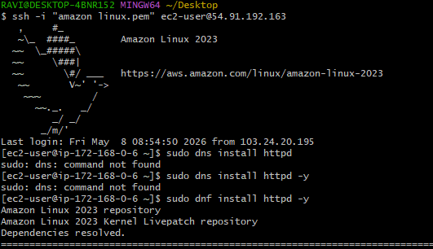 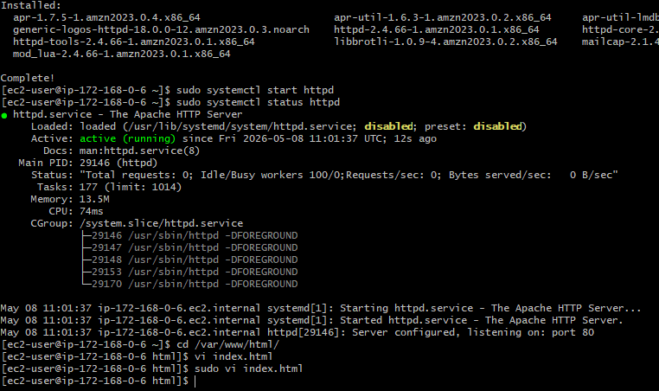
Created a new application load balancer and then created a new target group:
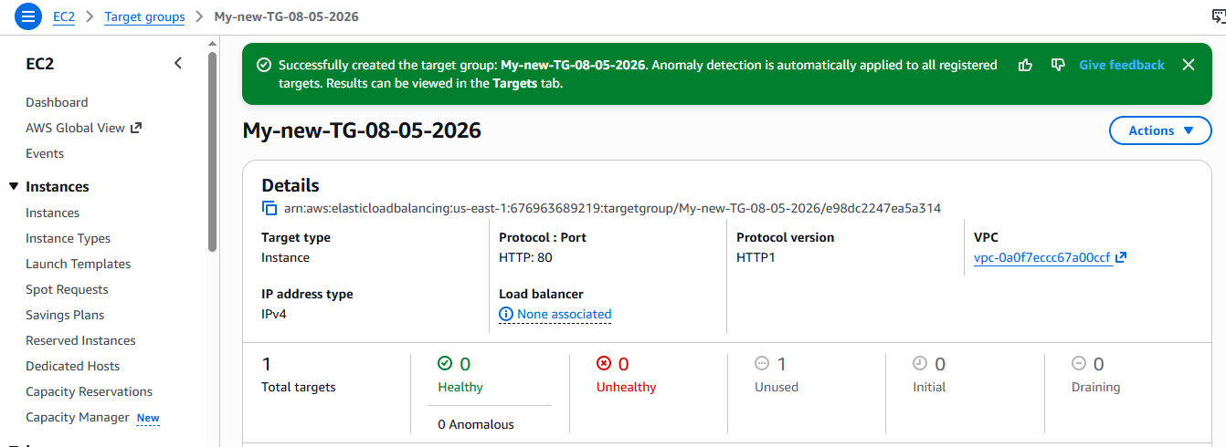
Created a two subents in two different zones:
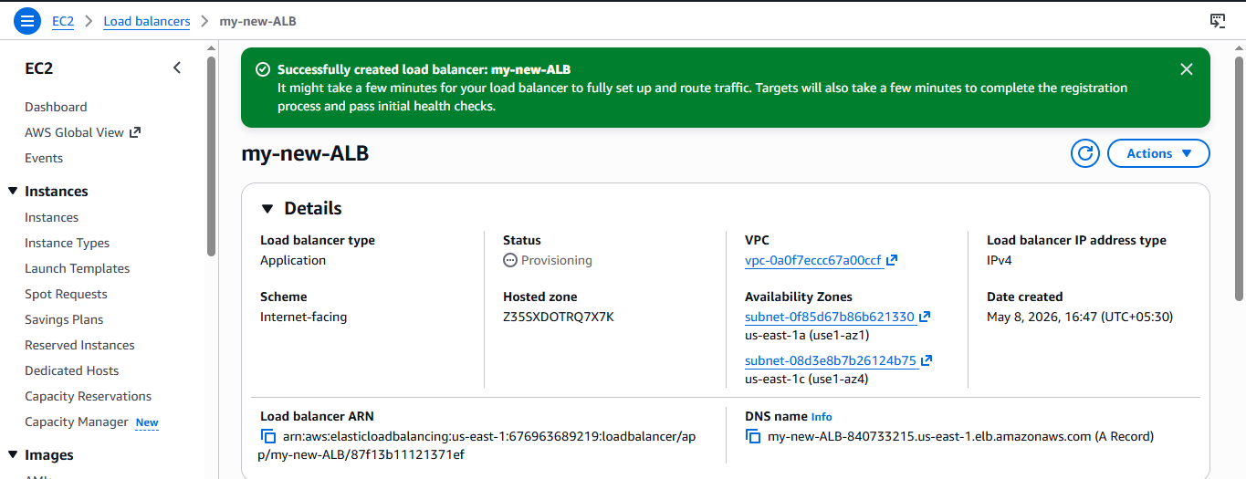
continued with DNS name in the browser:
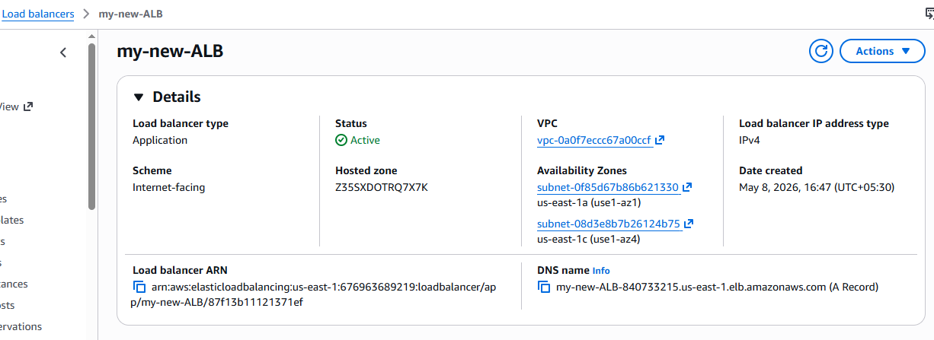 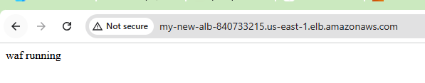
Created a new waf with acl:
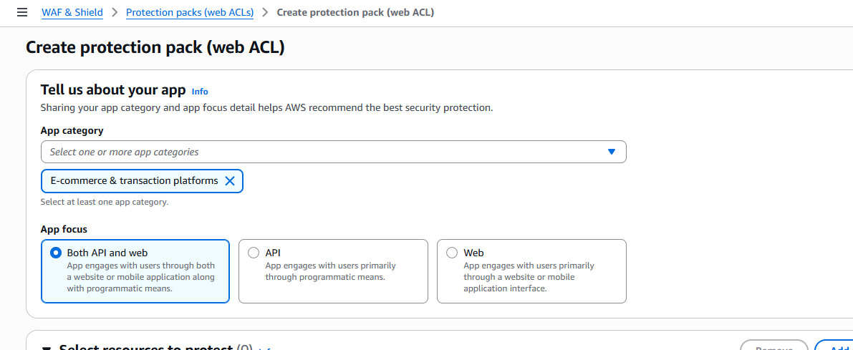
Click on add resources and then click on ELB:
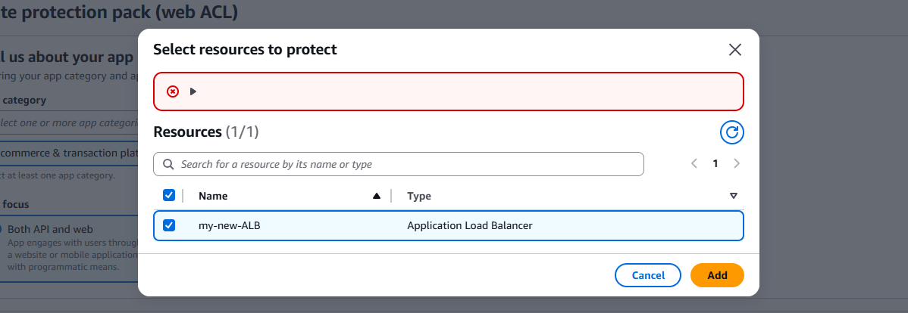
Then go to waf and then click on the same path shown below:
